**Project Milestone 5**

Astrid Fuentes, MS

Bellevue University

DSC 540: Data Preparation

Prof. Benjamin Schneider

March 4, 2021

**Introduction**

Throughout the term we have been building a project consistent of 5 milestones. Each milestone was intended to find, clean, and blend together 3 data sources related to the same topic and then try to answer some relevant questions with it using 5 different visualizations.

**Questions and Answers**

In Milestone 1, I chose 3 data sources related to Covid-19 and defined some questions I wanted to answer with this data. Let’s start by looking back at my original statistical questions and attempt to answer them:

1. Are the number of deaths higher in male patients than female?

The answer is yes, according to *Figure 1*, there are over 30 thousand more deaths in Males than Females across the United States. *Figures 2* and *3* show the total deaths per gender and state. We can clearly see in Figure 3 that all states have higher total deaths for Males than Females.

*Figure 1*.

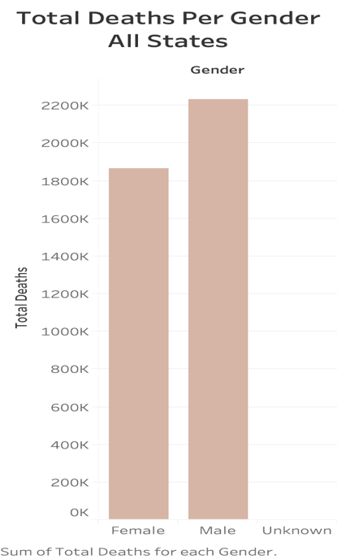

*Figure 2.*

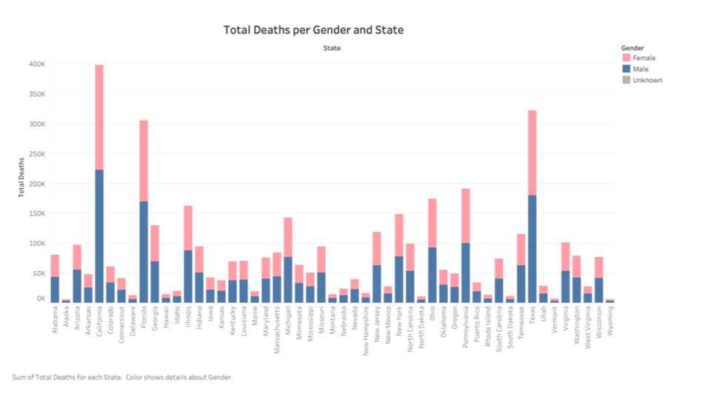

*Figure 3.*

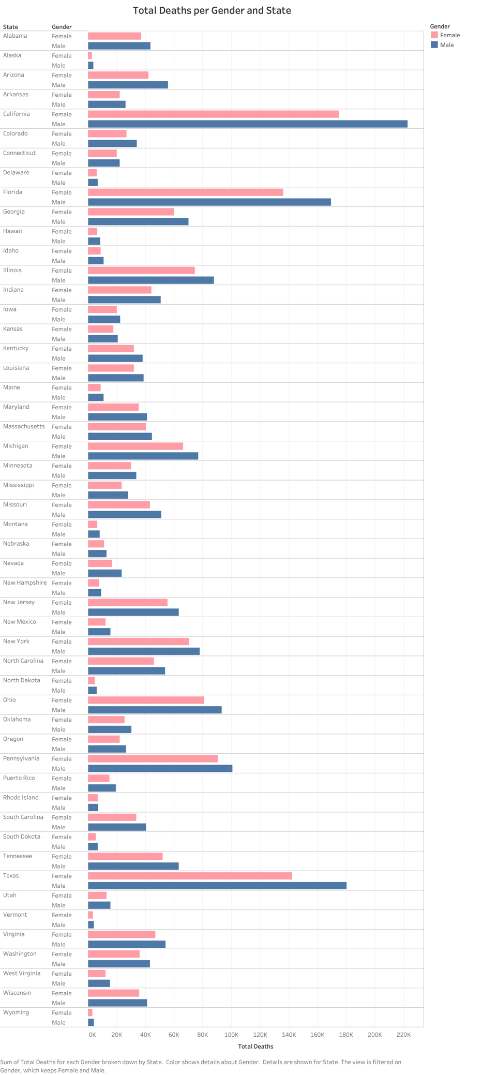

1. Are seniors’ death rate higher than non-senior?

Yes, *Figure 4* shows how total deaths increases considerably as the age group increases.

*Figure 4*.

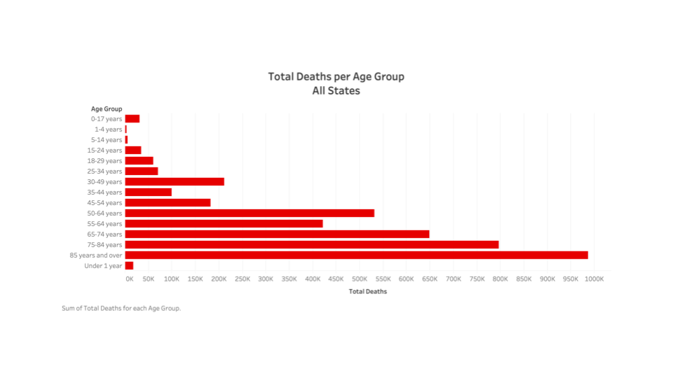

1. Examine the overall trend of the time series and how some of the variables might be contributing to that trend.

I was unable to answer this question at this time since the dates of report where the same for all records. I will need to obtain dates from another source to be able to create a time series.

1. Are number of deaths higher in certain states during a particular time-period. Possible causes?

*Figure 5* shows that the number of deaths is higher in states like California, Texas, New York, and Florida. Similar to the previous question, I was unable to include the time-period at this time.

*Figure 5.*

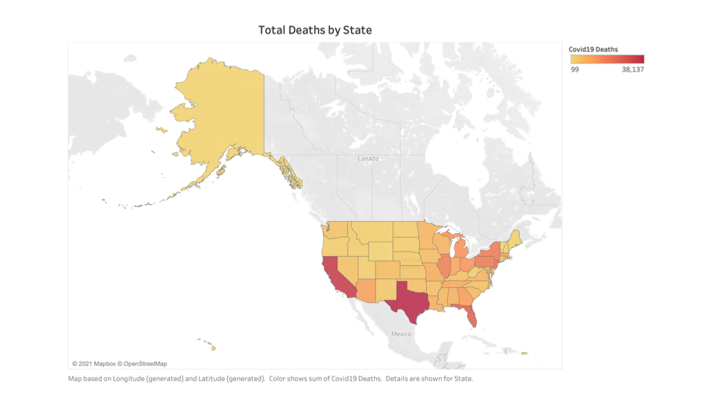

Additionally, *Figure 6* shows that the number of deaths is positively related to the size of the population, as the size of the population increases, the number of deaths by Covid-19 also increases.

*Figure 6.*

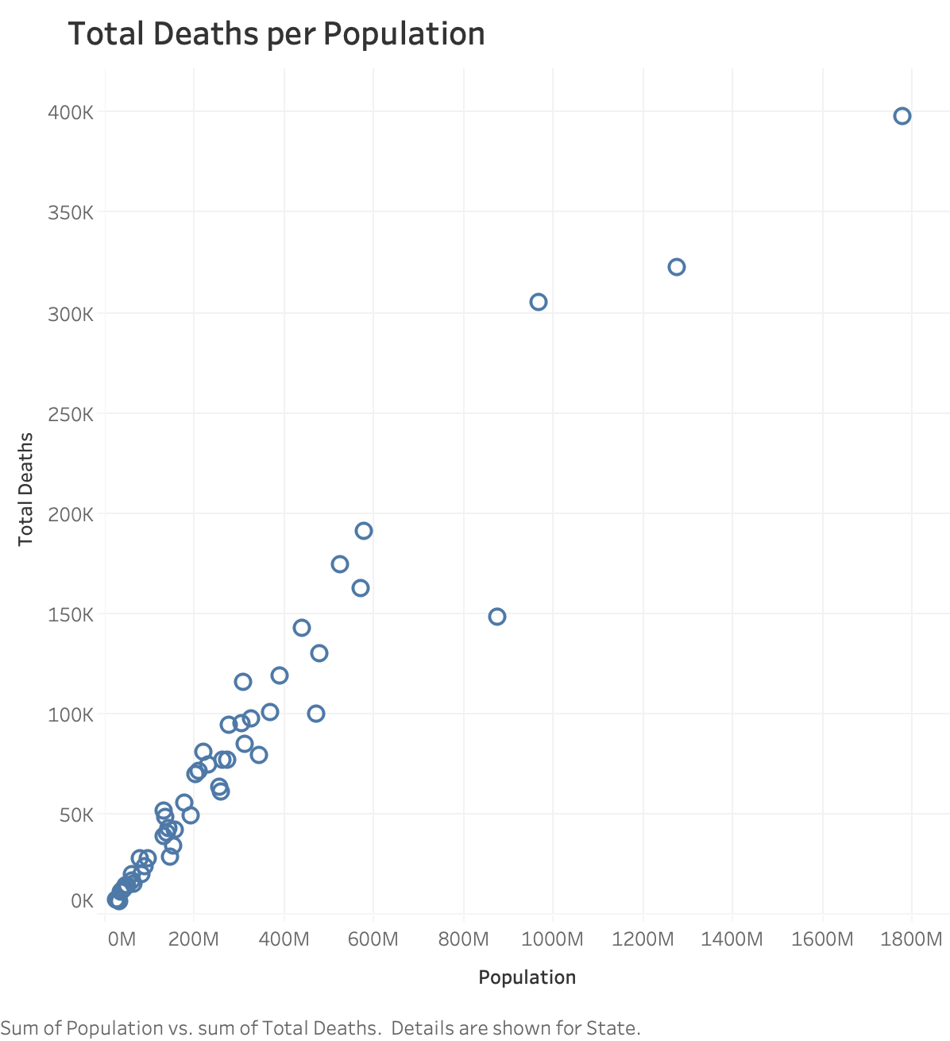

**Final Comments**

While working on this project I have learned to work with different data sources like flat files, web pages, APIs, etc. I have learned how to clean the data and perform basics checks for duplication, missing information, etc. I have learned to rename columns, replace nulls, and other cleaning and organizing activities.

Furthermore, I learned, not only to connect to a database, but also how to work with databases including creating tables, loading data to them, retrieving data, joining, etc.

Overall, I think this project is very helpful and I plan on keep working on it and improving it as time allows. I know there are things that I could do better but given time constrains I was unable to at this time.

**References**

*Center for Disease Control and Prevention: Provisional COVID-19 Death Counts by Sex, Age, and week.* <https://data.cdc.gov/NCHS/Provisional-COVID-19-Death-Counts-by-Sex-Age-and-W/vsak-wrfu/data>

*Worldometer: Coronavirus.* <https://www.worldometers.info/coronavirus/country/us/>

*The Covid Tracking Project.* <https://covidtracking.com/data/api>